**Project Specifications**

ECG classifier

* input : Digital ECG signals (from datasets - MIT) - Pathological and healthy ones
* Our device: Multiclass classifier -
* Arduino based, micro-controller
* Dataset trained classifier - Need to define classifiers - Compare them in terms of result, complexity, power…
* State of the art: different attempts have been made on costly microcontrollers with good results.
* Goal is to make a good enough classifier but using the arduino nano RP2040 connect.
* Low-price classifier that could be expanded for health monitoring for all budgets.
* Initially: try to separate healthy/unhealthy ecg recordings in an efficient way (computational + power efficient).
* Then try to implement a multi-class classifier.
* No need for more than the Arduino Nano RP2040 connect.

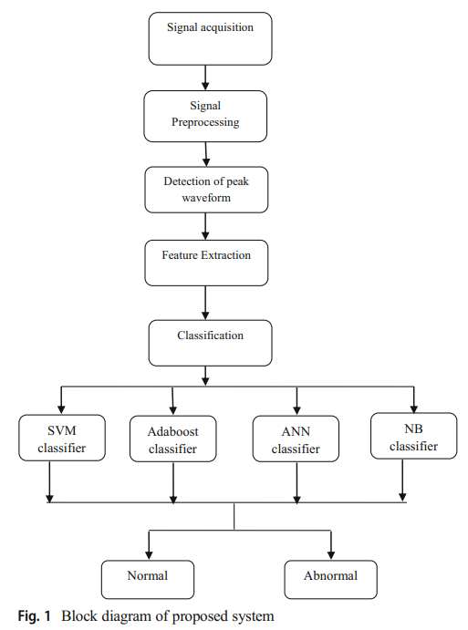

General building blocks that could be used. In this article, comparison of different deep learning algorithms → try to implement and compare them using embedded computing. [1]

ECG generator:

* Input : specific type of ecg demanded by the user (bpm, pathological/healthy, HRV…)
* Device: generation of the specific ecg using GAN techniques
* Output of an analog signal based on digital signals
* Architecture: Microcontroller → DAC.
* **Feature extraction ??**

1. ECG Signal Classification Using Various Machine Learning Techniques, S. Celin et. al, 2018